CIS 182 – SQL Fundamentals – Winter 2024

W11 Exercises: Creating a Database on Azure

(For the due date, please refer to this lab’s posting on Canvas)

Exercises

In these exercises, you’ll work online with Azure to create a database.

*Note: make sure you have a student Azure account.*

Once you have an Azure account, you can then start using its many services. Login at

<https://portal.azure.com> and you will be redirected to your Azure home page:

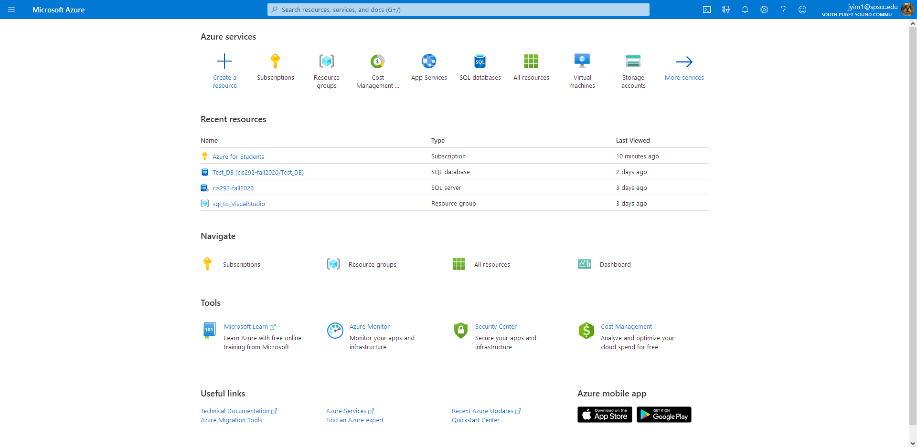

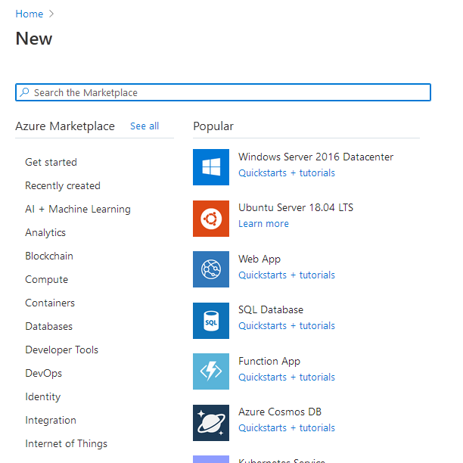To create a new database on Azure, click the “+” at the top of the home page that says “create a resource”. You will then be redirected to a searchable list of the Azure marketplace’s resources.

If you do not see “SQL Database” listed under the “Popular” column, simply search for it in the search bar.

You will be brought to the Database creation page which has many different options to setup a fully functional database. Consult with your instructor to decide which is the best option for you. The next part of the guide will go through the basic process to begin a small database that is best for small data and educational purposes.

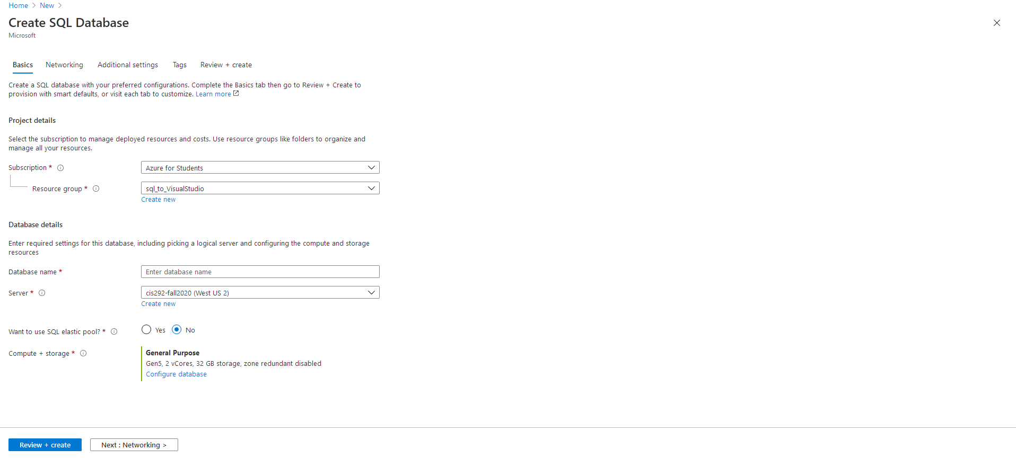

If this is the first time you are creating a database on your Azure subscription, you will also have to create a **resource group** and **server**. Microsoft defines a resource group as “a collection of resources that share the same lifecycle, permissions, and policies”.

Under the Server dropdown field, you may click “create new” to setup a new server for your database.

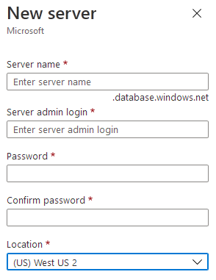

Make sure to save your login credentials! Server name, admin login, and the password are all needed if you want to use this server.

Next, choose your compute & storage options at the bottom of the page

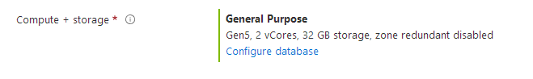

Clicking “configure database” will allow you to choose cheaper options that can make your subscription last longer.

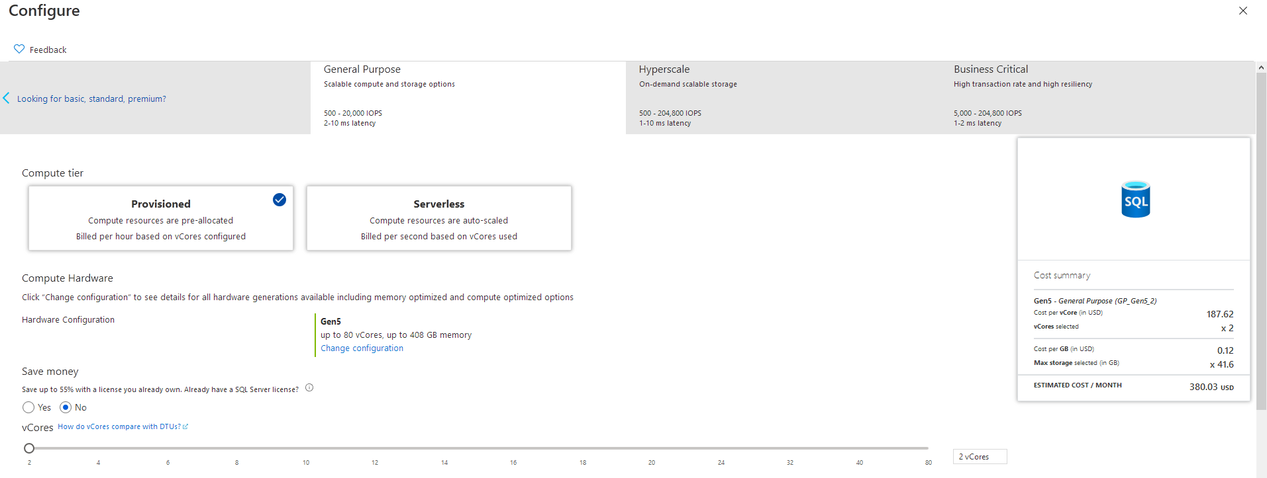

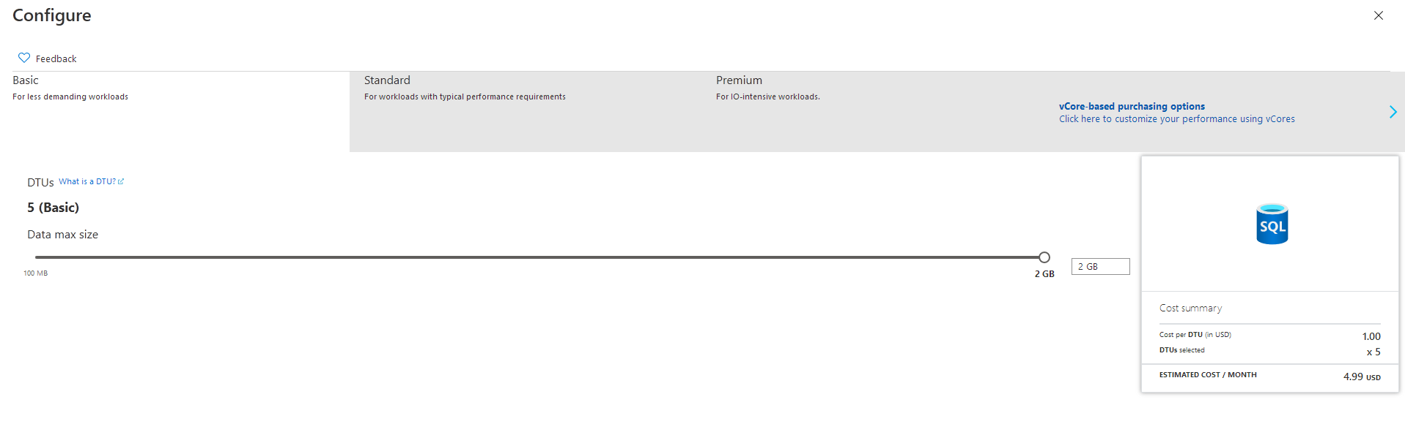

Note the differences between the basic and general purpose options.

Once you have selected all your desired options, you can proceed to finish and create the database.

Once created, you can see it from your Azure portal home,

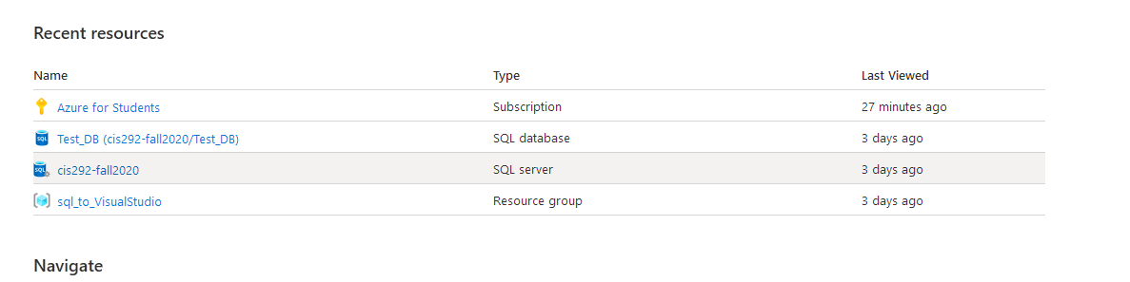

Click on the database to navigate to its overview page.

One of the first things you should do to enable working with your DB online is to ensure you can access it from whatever machine you are working from.

Click “set server firewall”:

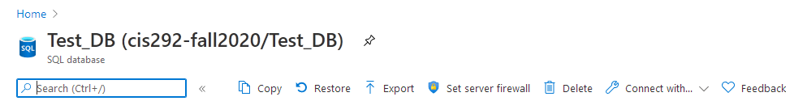

Then at the top click “Add client IP”

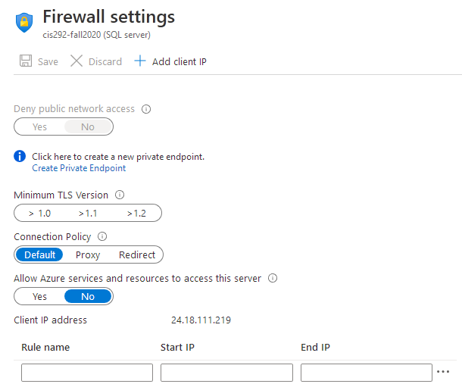

This will automatically add your machine’s IP address to the list of Client IP addresses found at the bottom of the page. You may edit them directly or delete them by clicking the “**…**” next to each entry.

Once your IP is allowed to connect to the server, you can start writing SQL code to edit your database!

Click editor preview to open the in-browser script editor.

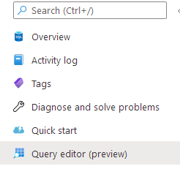

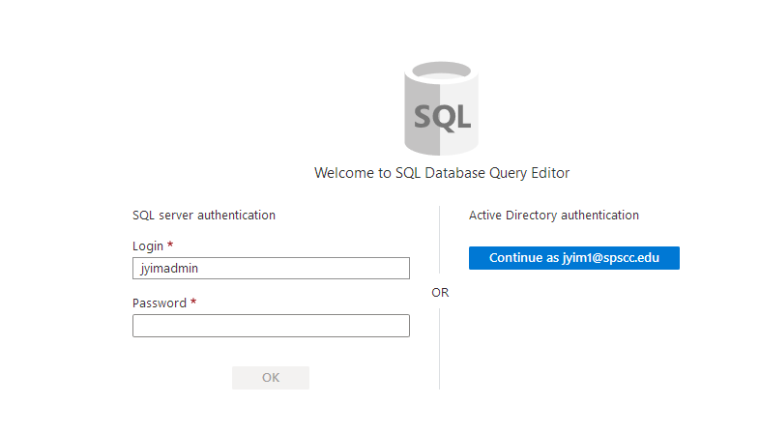

Enter your **server** login information on the left. Note that this login is the one you created when you first created the server.

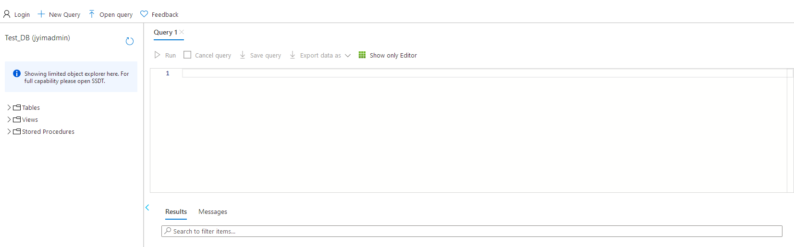

The window will refresh, displaying the editor in your browser! You may start writing code here, and also interact with the file tree on the left to navigate your database objects.